**Homework 2**

**Canny Edge Detector**

**Sahithi Muppiri**

**Canny edge detector algorithm:**

This is a method to detect edges in an image while suppressing noise.

**Input images.**

The following images are considered through the assignment.

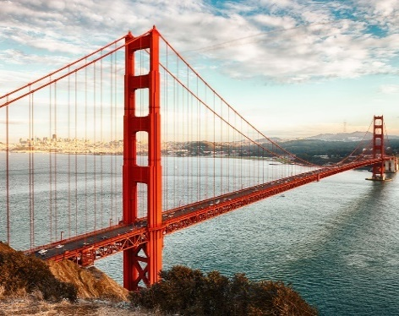 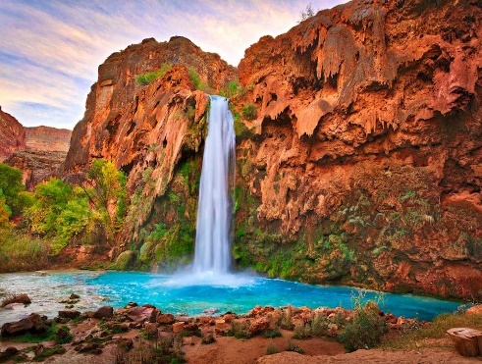 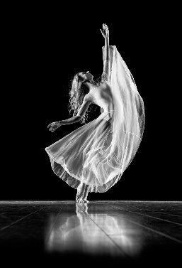

**Output:**

**By using OpenCV library.**

A one-line code, by using the OpenCV library. The line 7 as shown in the image takes 6 arguments. Namely, edges, threshold1, threshold2, aperture size and L2gradient. This method takes the input image and marks the edges for the same.

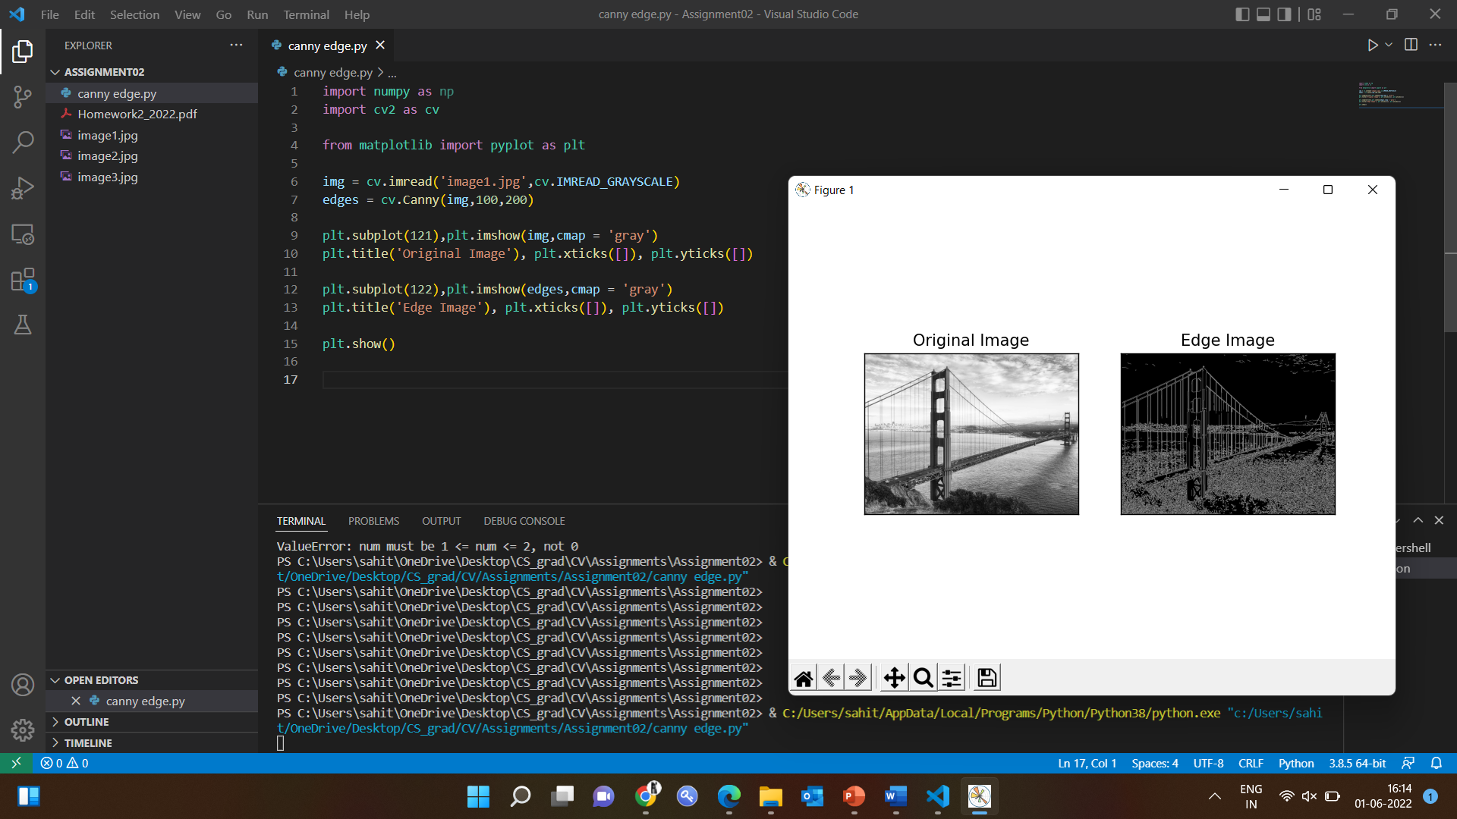

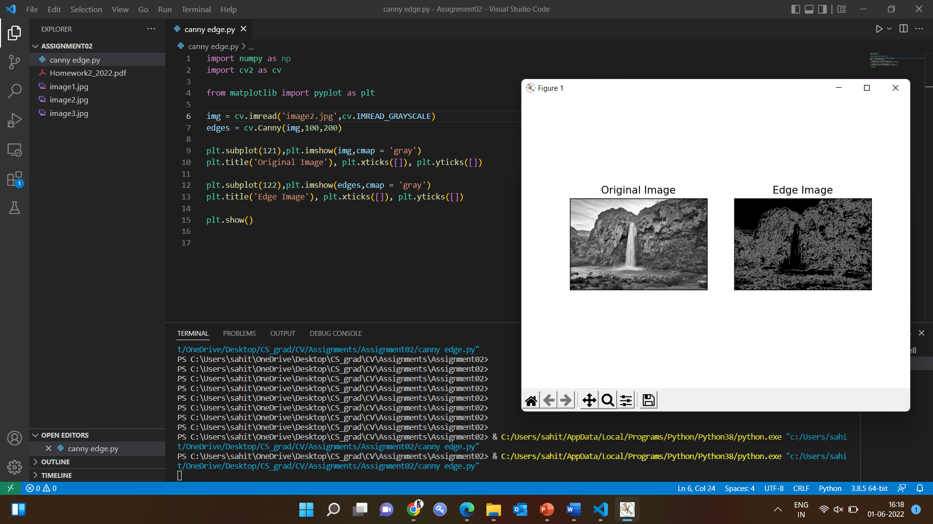

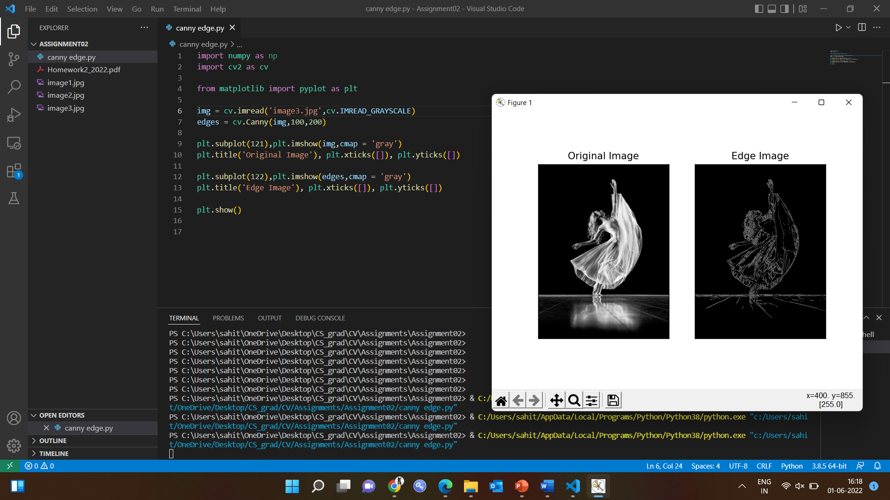

**Without OpenCV, custom built 5 step canny edge detection algorithm:**

Step 0: Read the image and convert to grey scale

To run the script faster convert the image with the RGB values to grey scale values. The intensity values will be 8 bits ranging from 0 to 255.

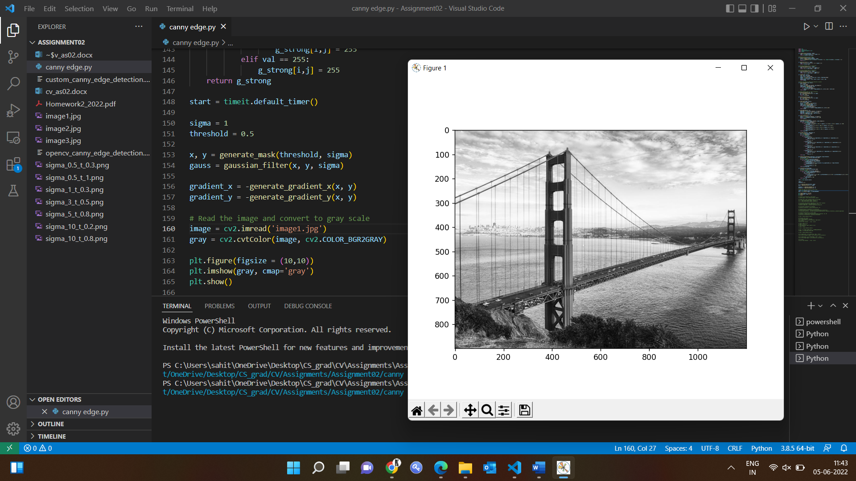

Step 1: Noise reduction

Reduce the intensity of the pixels in the image as it would lead to large mathematical values while computing the derivatives (Gradient Calculation) and since they are sensitive to image noise.

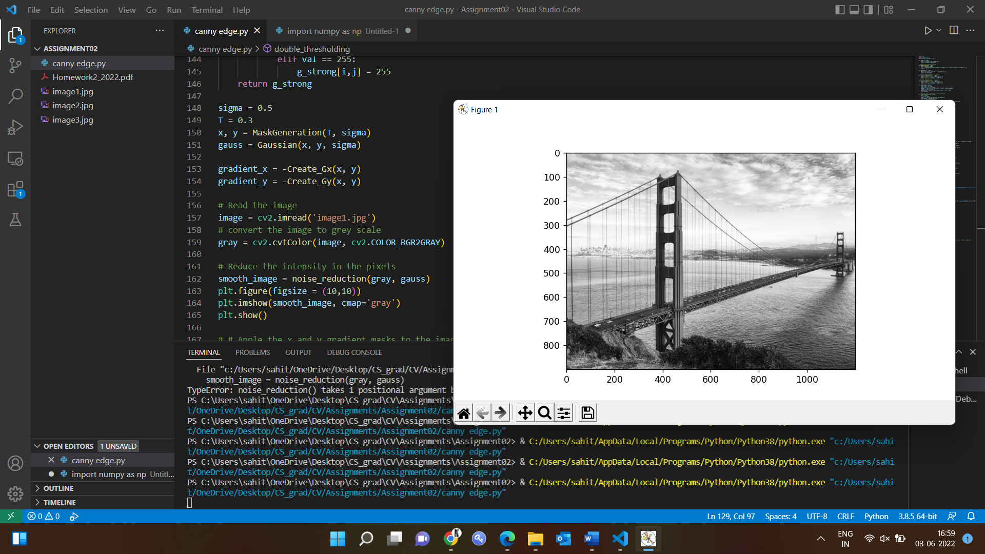

Step 2: Gradient calculation.

The edge detection operators are used to detect the edge direction and intensity of the image. Filters are computed for the image for x and y directions. The mask for the images in x and y direction are calculated and applied to the image.

1. Gradient x-direction mask when applied to image

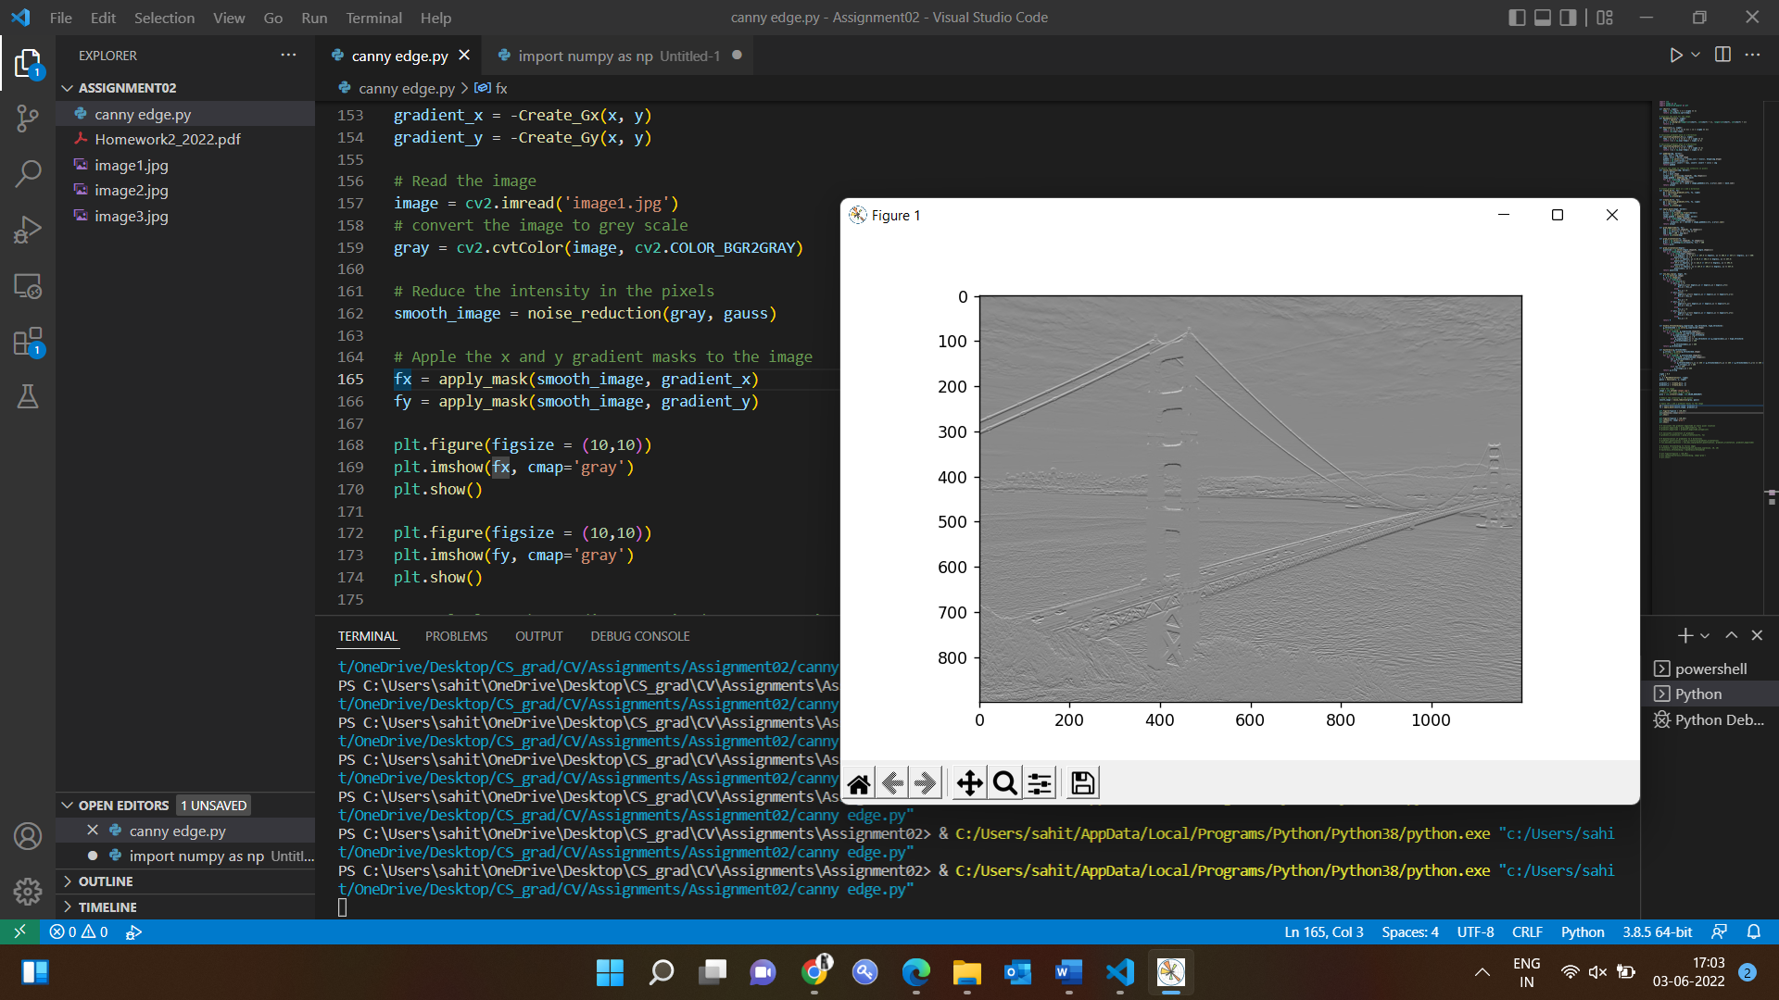

1. Gradient y-direction mask when applied to image

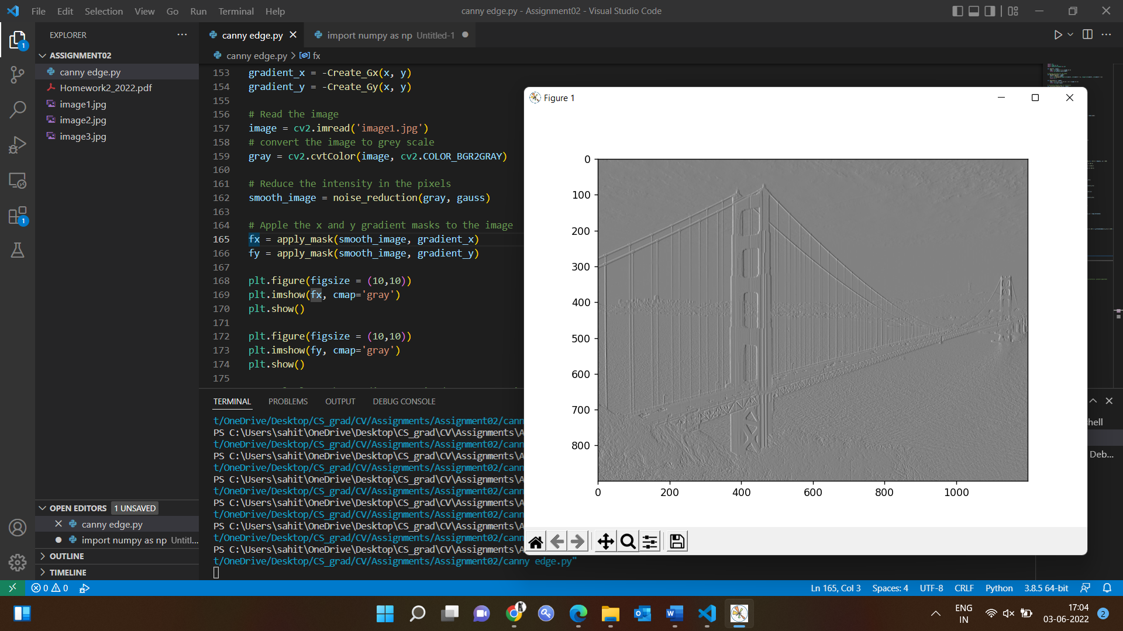

Step 3: Non-maximum suppression.

The gradient direction is quantized into 4 directions and the next step is to apply non maximum suppression by detecting two neighbours of each edge point to display thin edges.

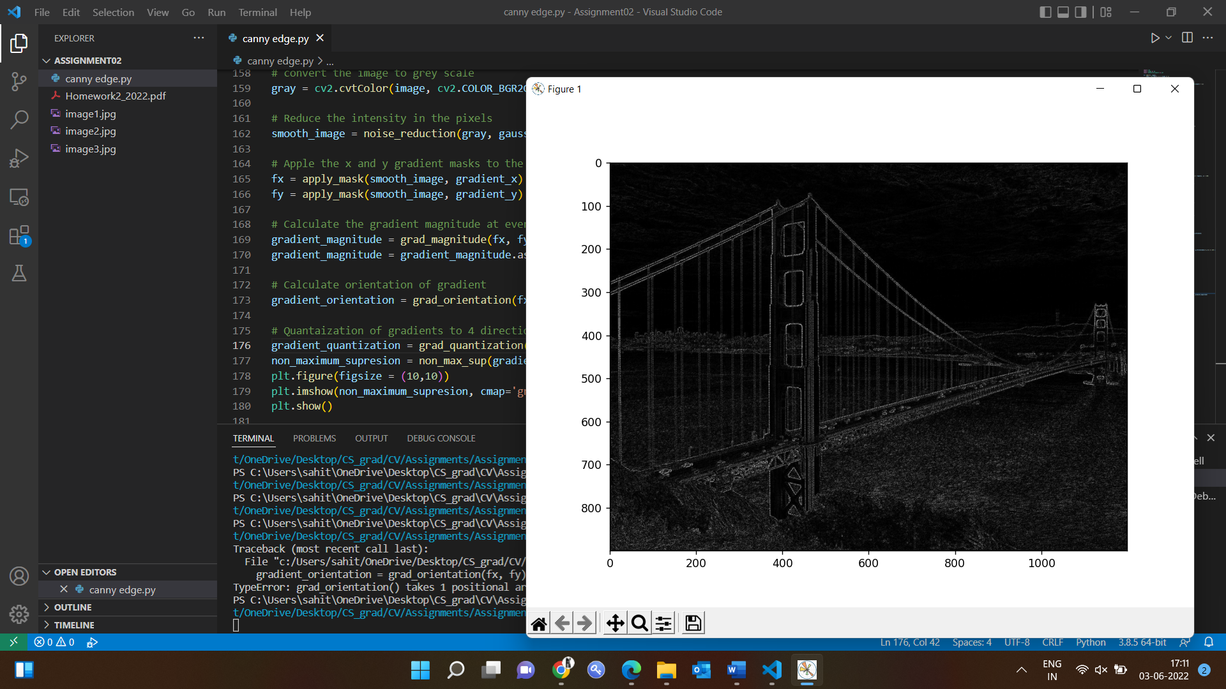

Step 4: Double threshold.

Three kinds of pixels are identified in here.

1. Strong pixels: high intensity pixels.
2. Weak pixels: pixel intensity is so minimal that they are not able to detect the edge.
3. Other pixels: the ones which are not considered to be the edge.

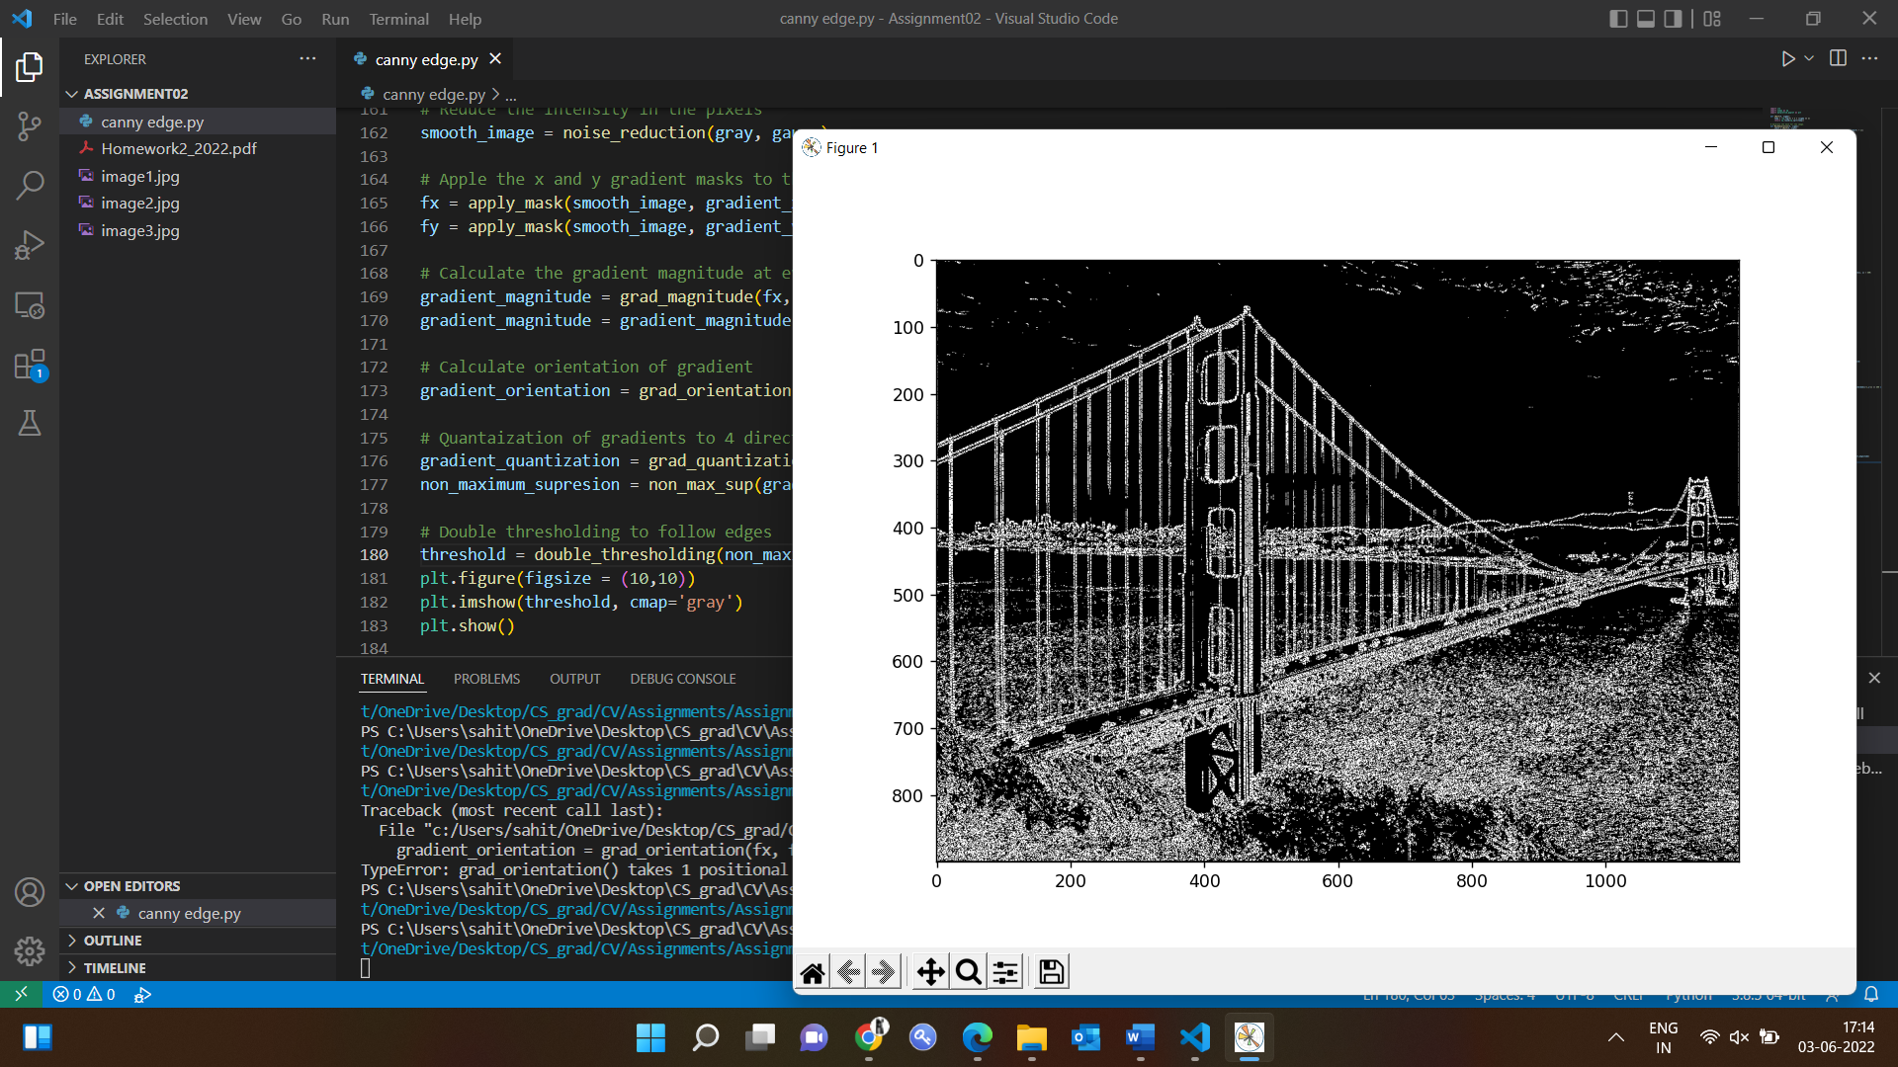

Step 5: Edge Tracking by Hysteresis.

Hysteresis transforms weak intensity pixels to stronger ones for edge detection, only when any one of the adjacent pixels is stronger one.

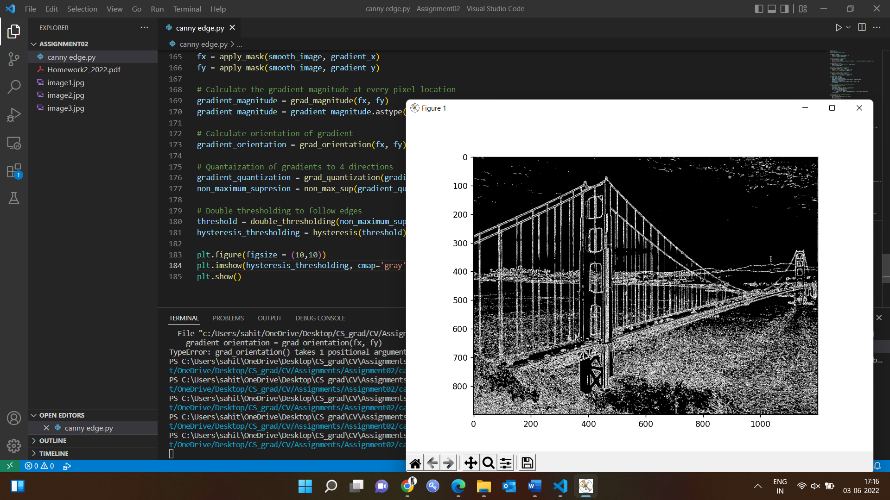

Output:

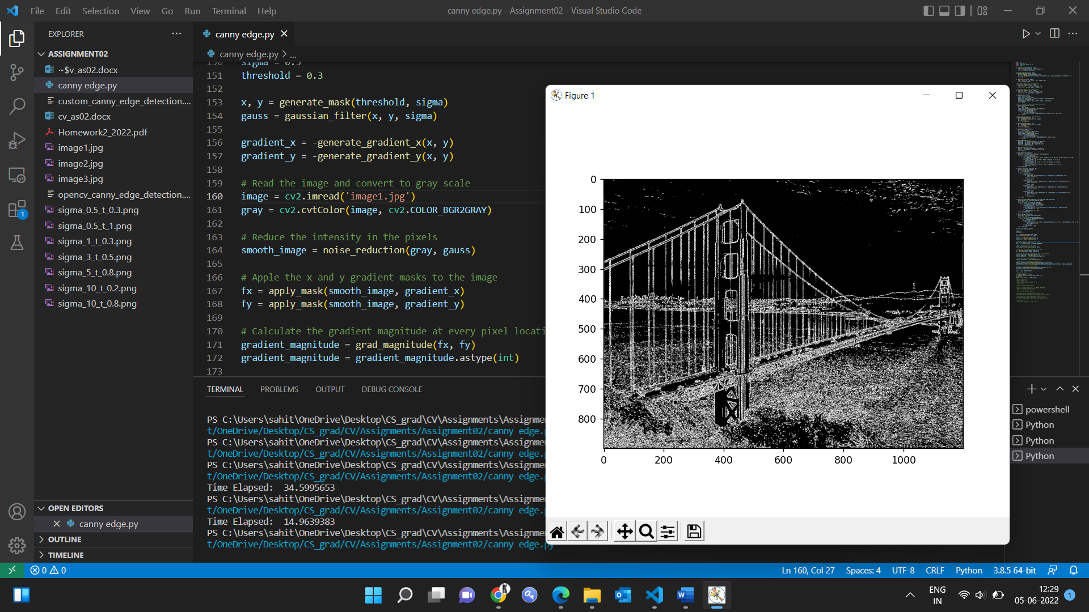

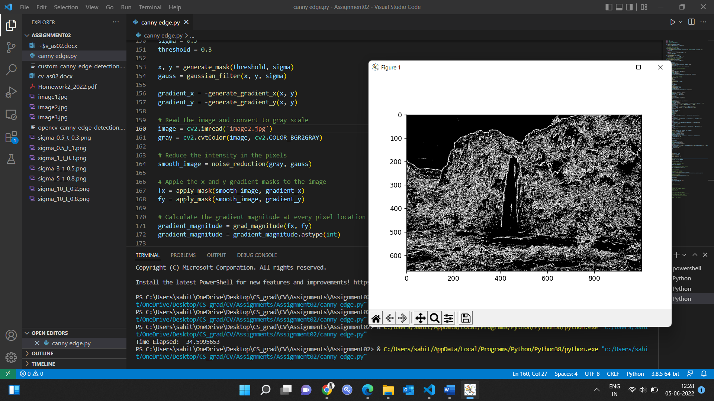

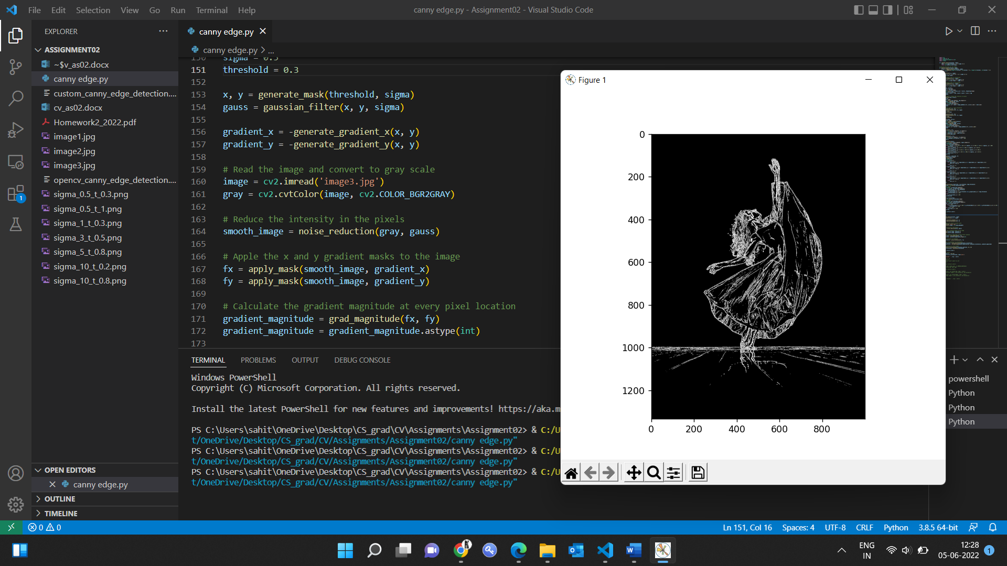

**Apply different sigma and different thresholding (high-low) and discuss the results**

1. When sigma = 0.5 and threshold = 0.3

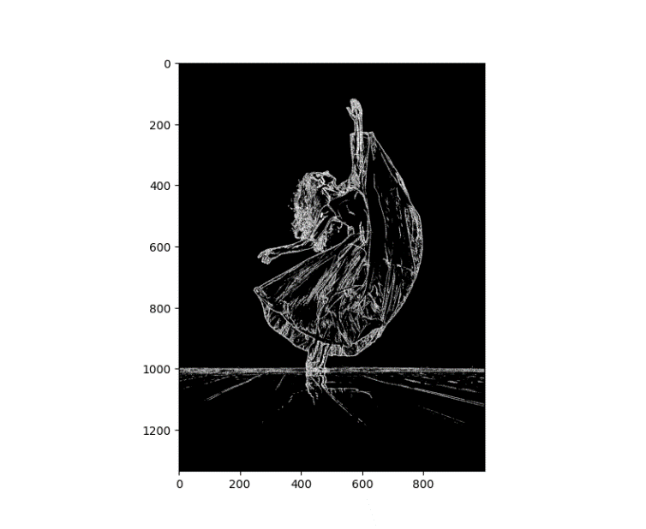

1. When sigma = 0.5 and threshold = 1

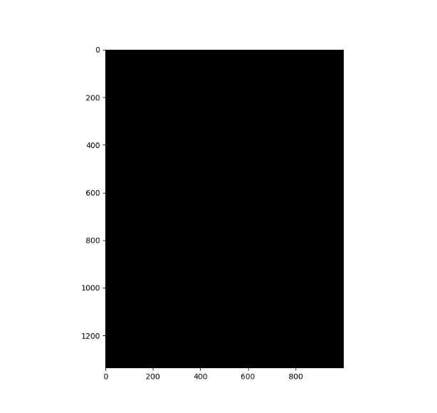

1. When sigma = 1 and threshold = 0.3

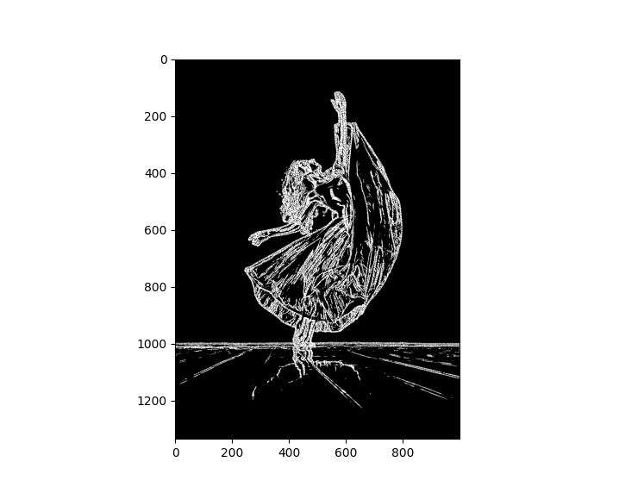

1. When sigma = 3 and threshold = 0.5

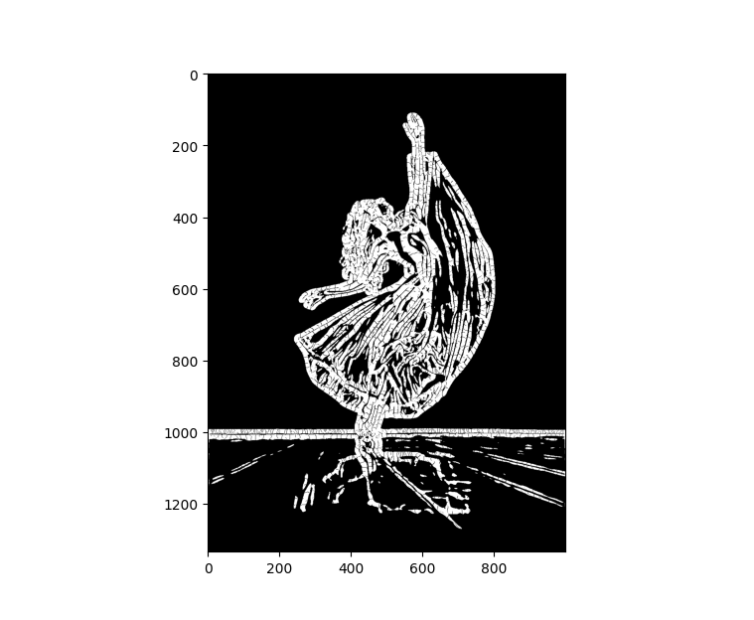

1. When sigma = 5 and threshold = 0.8

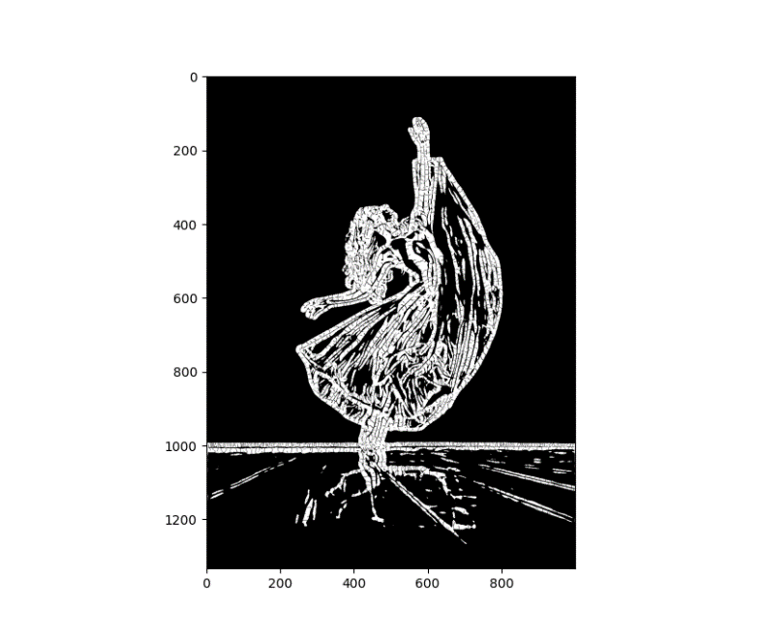

1. When sigma = 10 and threshold = 0.2

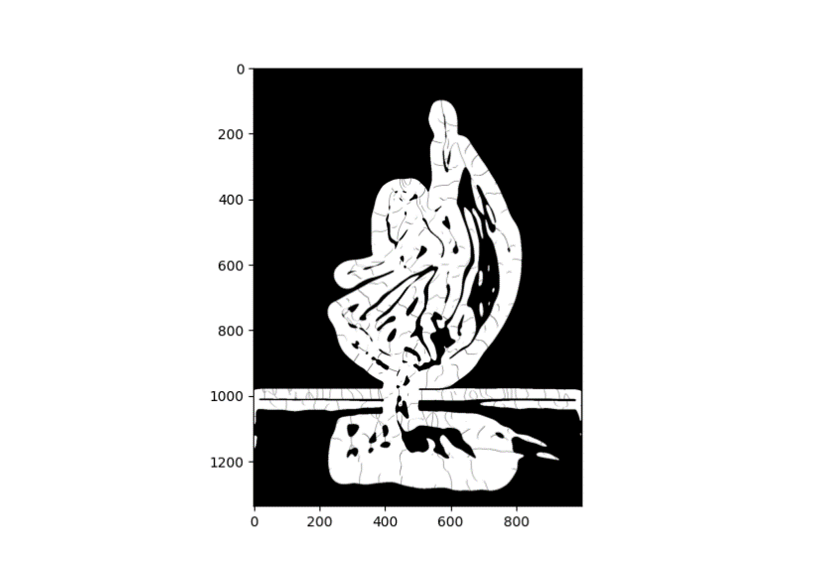

1. When sigma = 10 and threshold = 0.8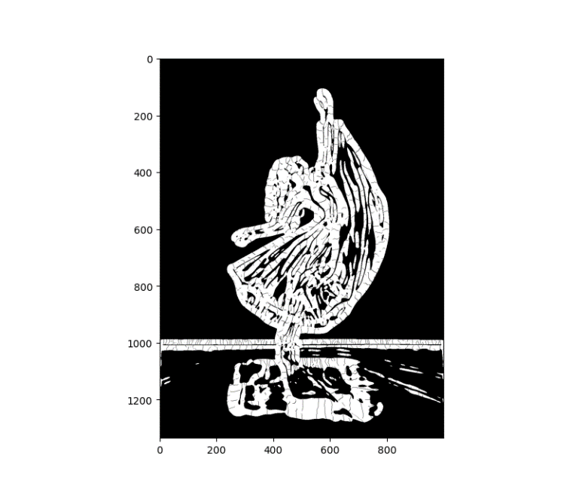

**Results:**

When the sigma values are higher, we observe that the edge scales are coarser and when the sigma values are smaller, we observe finer edge scales.

The threshold value is normalized to be in range between 0 to 1. The pixels with a high value than the threshold is most likely to be the edges. Ex: In the above two images (7) and (8), consider the (8) with the threshold 0.8, so the pixels larger than 0.8 will be a strong edge. And as we can observe that the edges can be seen clearly whereas in (7) with threshold 0.2, there is no clear edge.

**Code:**

**Using OpenCV library.**

import numpy as np

import cv2 as cv

from matplotlib import pyplot as plt

import timeit

start = timeit.default_timer()

img = cv.imread('image1.jpg', cv.IMREAD_GRAYSCALE)

edges = cv.Canny(img, 100, 200)

stop = timeit.default_timer()

plt.subplot(121), plt.imshow(img, cmap = 'gray')

plt.title('Original Image'), plt.xticks([]), plt.yticks([])

plt.subplot(121), plt.imshow(edges, cmap = 'gray')

plt.title('Edge Image'), plt.xticks([]), plt.yticks([])

plt.show()

print('Time Elapsed: ', stop - start)

**Without using OpenCV library:**

import cv2

import numpy as np

import matplotlib.pyplot as plt

import timeit

def compute_values(threshold, sigma):

temp = -np.log(threshold) * 2 * (sigma ** 2)

return np.round(np.sqrt(temp))

# Generate the mask for the image.

def generate_mask(threshold, sigma):

values = compute_values(threshold, sigma)

y, x = np.meshgrid(range(-int(values), int(values) + 1), range(-int(values), int(values) + 1))

return x, y

def gaussian_filter(x,y, sigma):

temp = ((x ** 2) + (y ** 2)) / (2 * (sigma ** 2))

return (np.exp(-temp))

# Calculate gradient mask in x-direction

def calculate_gradient_X(x,y, sigma):

temp = (x ** 2 + y ** 2) / (2 * sigma ** 2)

return -((x * np.exp(-temp)) / sigma ** 2)

# Calculate gradient mask in y-direction

def calculate_gradient_Y(x,y, sigma):

temp = (x ** 2 + y ** 2) / (2 * sigma ** 2)

return -((y * np.exp(-temp)) / sigma ** 2)

def padding(img, kernel):

rows, cols = img.shape

krows, kcols = kernel.shape

padded = np.zeros((rows + krows,cols + kcols), dtype=img.dtype)

insert = np.uint((krows)/2)

padded[insert: insert + rows, insert: insert + cols] = img

return padded

# Smooth the image to reduce the intensity in pixels

def noise_reduction(img, kernel):

mask = kernel

i, j = mask.shape

output = np.zeros((img.shape[0], img.shape[1]))

image_padded = padding(img, mask)

for x in range(img.shape[0]):

for y in range(img.shape[1]):

output[x, y] = (mask * image_padded[x:x+i, y:y+j]).sum() / mask.sum()

return output

# Create gradient mask in x and y direction

def generate_gradient_x(fx, fy):

gx = calculate_gradient_X(fx, fy, sigma)

gx = (gx * 255)

return np.around(gx)

def generate_gradient_y(fx, fy):

gy = calculate_gradient_Y(fx, fy, sigma)

gy = (gy * 255)

return np.around(gy)

def apply_mask(image, kernel):

i, j = kernel.shape

kernel = np.flipud(np.fliplr(kernel))

output = np.zeros_like(image)

image_padded = padding(image, kernel)

for x in range(image.shape[0]):

for y in range(image.shape[1]):

output[x, y] = (kernel * image_padded[x:x+i, y:y+j]).sum()

return output

def grad_magnitude(fx, fy):

magnitude = np.zeros((fx.shape[0], fx.shape[1]))

magnitude = np.sqrt((fx ** 2) + (fy ** 2))

magnitude = magnitude * 100 / magnitude.max()

return np.around(magnitude)

def grad_orientation(fx, fy):

grad_or = np.zeros((fx.shape[0], fx.shape[1]))

grad_or = np.rad2deg(np.arctan2(fy, fx)) + 180

return grad_or

def grad_quantization(angle):

quantized = np.zeros((angle.shape[0], angle.shape[1]))

for i in range(angle.shape[0]):

for j in range(angle.shape[1]):

if 0 <= angle[i, j] <= 22.5 or 157.5 <= angle[i, j] <= 202.5 or 337.5 < angle[i, j] < 360:

quantized[i, j] = 0

elif 22.5 <= angle[i, j] <= 67.5 or 202.5 <= angle[i, j] <= 247.5:

quantized[i, j] = 1

elif 67.5 <= angle[i, j] <= 122.5 or 247.5 <= angle[i, j] <= 292.5:

quantized[i, j] = 2

elif 112.5 <= angle[i, j] <= 157.5 or 292.5 <= angle[i, j] <= 337.5:

quantized[i, j] = 3

return quantized

def non_max_sup(quant, magnitude, D):

nms = np.zeros(quant.shape)

a, b = np.shape(quant)

for i in range(a-1):

for j in range(b-1):

if quant[i,j] == 0:

if magnitude[i,j-1]< magnitude[i,j] or magnitude[i,j] > magnitude[i,j+1]:

nms[i,j] = D[i,j]

else:

nms[i,j] = 0

if quant[i,j]==1:

if magnitude[i-1,j+1]<= magnitude[i,j] or magnitude[i,j] >= magnitude[i+1,j-1]:

nms[i,j] = D[i,j]

else:

nms[i,j] = 0

if quant[i,j] == 2:

if magnitude[i-1,j]<= magnitude[i,j] or magnitude[i,j] >= magnitude[i+1,j]:

nms[i,j] = D[i,j]

else:

nms[i,j] = 0

if quant[i,j] == 3:

if magnitude[i-1,j-1]<= magnitude[i,j] or magnitude[i,j] >= magnitude[i+1,j+1]:

nms[i,j] = D[i,j]

else:

nms[i,j] = 0

return nms

def double_thresholding(g_suppressed, low_threshold, high_threshold):

g_thresholded = np.zeros(g_suppressed.shape)

# loop over pixels

for i in range(0, g_suppressed.shape[0]):

for j in range(0, g_suppressed.shape[1]):

if g_suppressed[i,j] < low_threshold:

g_thresholded[i,j] = 0

elif g_suppressed[i,j] >= low_threshold and g_suppressed[i,j] < high_threshold:

g_thresholded[i,j] = 128

else:

g_thresholded[i,j] = 255

return g_thresholded

def hysteresis(g_thresholded):

g_strong = np.zeros(g_thresholded.shape)

# loop over pixels

for i in range(0, g_thresholded.shape[0]):

for j in range(0, g_thresholded.shape[1]):

val = g_thresholded[i,j]

if val == 128:

if g_thresholded[i-1,j] == 255 or g_thresholded[i+1,j] == 255 or g_thresholded[i-1,j-1] == 255 or g_thresholded[i+1,j-1] == 255 or g_thresholded[i-1,j+1] == 255 or g_thresholded[i+1,j+1] == 255 or g_thresholded[i,j-1] == 255 or g_thresholded[i,j+1] == 255:

g_strong[i,j] = 255

elif val == 255:

g_strong[i,j] = 255

return g_strong

start = timeit.default_timer()

sigma = 1

threshold = 0.5

x, y = generate_mask(threshold, sigma)

gauss = gaussian_filter(x, y, sigma)

gradient_x = -generate_gradient_x(x, y)

gradient_y = -generate_gradient_y(x, y)

# Read the image and convert to gray scale

image = cv2.imread('image3.jpg')

gray = cv2.cvtColor(image, cv2.COLOR_BGR2GRAY)

# Reduce the intensity in the pixels

smooth_image = noise_reduction(gray, gauss)

# Apple the x and y gradient masks to the image

fx = apply_mask(smooth_image, gradient_x)

fy = apply_mask(smooth_image, gradient_y)

# Calculate the gradient magnitude at every pixel location

gradient_magnitude = grad_magnitude(fx, fy)

gradient_magnitude = gradient_magnitude.astype(int)

# Calculate orientation of gradient

gradient_orientation = grad_orientation(fx, fy)

# Quantaization of gradients to 4 directions

gradient_quantization = grad_quantization(gradient_orientation)

non_maximum_supresion = non_max_sup(gradient_quantization, gradient_orientation, gradient_magnitude)

# Double thresholding to follow edges

threshold = double_thresholding(non_maximum_supresion, 10, 10)

hysteresis_thresholding = hysteresis(threshold)

stop = timeit.default_timer()

# Display the output

plt.figure(figsize = (10,10))

plt.imshow(hysteresis_thresholding, cmap='gray')

plt.show()

print('Time Elapsed: ', stop - start)

**With the implementation of OpenCV and without using the OpenCV library, observed the following changes in the code:**

With the use of OpenCV library, the first step it does is removing the noise by using gaussian 5 x 5 filter. We manually do this in the custom-built function. The gradient intensity in the XY direction is calculated using the formula in both the images. Non-maximum suppression and hysteresis remains the same in both the methods.

The only difference is that in the earlier versions, there is no gaussian blur in OpenCV. Canny method. This used to be called before the method. Whereas in the latest OpenCV. Canny this is performed within the method. The rest of the differences observed are as below.

|  |  |  |
| --- | --- | --- |
|  | **With OpenCV** | **Without OpenCV Library** |
| Implementation time | 0.0615151999 seconds | 10.3579463 seconds |
| Lines of Code | ~20 lines | ~200 lines |
| Language | Python | Python |
| Difficulty | Simple | Detailed |